Title of the abstract

E. López1, G. Möller2 and P. Yu2 (Example of authors)

1 Authors affiliation 1

2 Authors affiliation 2

Authors are kindly requested to follow these instructions for the preparation of their abstract. The abstract should be written in English, limited to one page of Letter format. Both left-right and top-bottom margins have to be 2.5 cm. All references within the text should be numbered consecutively in square brackets [1]. There is no limit in the number of figures used for the abstract. They should be named as Fig. 1, Fig. 2, etc.

To use this template, replace the text of this template with your text.

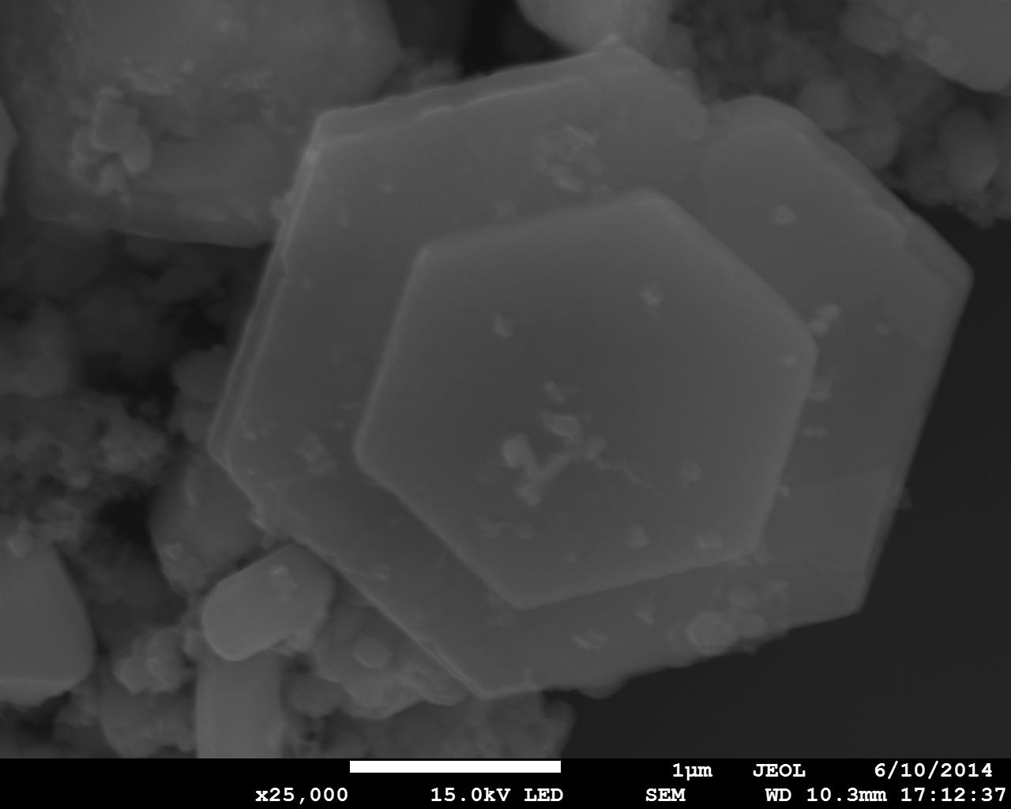

**Fig. 1:** Here you can add the caption of the figure.

References

[1] E. López, P. Yu, *Journal Name*, **44** (1999) 1000.